# Lab 9 - Backing Up, Restoring and Resizing Clusters

Objs-

1. Create a manual snapshot of an Amazon Redshift cluster
2. Restore an Amazon Redshift table from a snapshot
3. Restore an Amazon Redshift cluster from a snapshot

**Task 1: Adding tables to the cluster**

1.1 connect to pgweb, make table

*CREATE TABLE customer (*

*name VARCHAR(30),*

*phone VARCHAR(20)*

*);*

*INSERT INTO customer VALUES*

*('Arthur Dent', '1-101-867-5309'),*

*('Ford Prefect', '1-101-555-0101');*

1.2 by default - tables are backed up

To create a no backup table

*CREATE TABLE report_staging (*

*report_name VARCHAR(20),*

*status VARCHAR(10)*

*)*

*BACKUP NO;*

*INSERT INTO report_staging VALUES*

*('Sales Report', 'Complete'),*

*('Commission Report', 'Cancelled');*

**

**Task 2: Creating a manual snapshot**

Note - for automated backup snapshots

1. **Snapshot Frequency:**

- Taken every 8 hours or after 5 GB data changes per node.

2. **Retention Period:**

- Default retention period is 1 day.

3. **Manual Copy:**

- Create a manual snapshot to retain longer.

2.1 open RS in console, select ur cluster

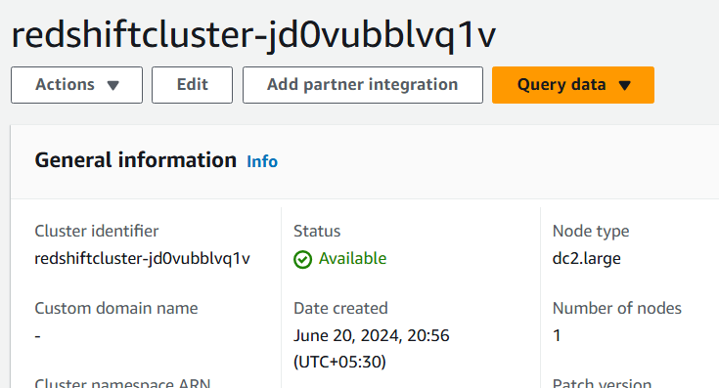

2.2 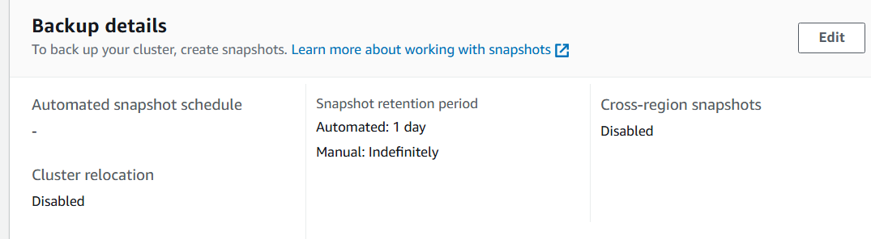

2.3

Go to actions to create SS

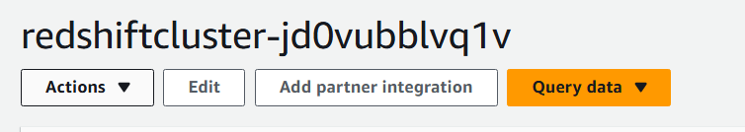

2.4 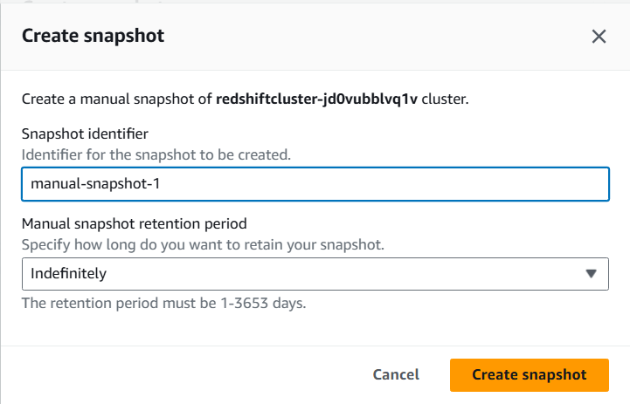

2.5

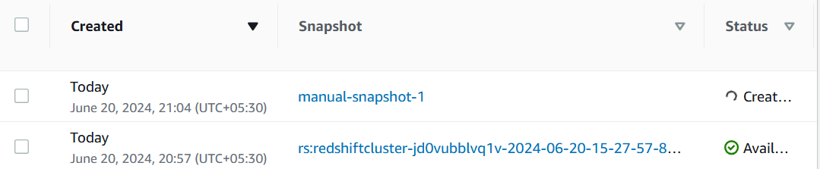

**Task 3: Restoring a cluster from a snapshot**

3.1 delete table

*DROP TABLE customer*

3.2 choose



3.3 deets

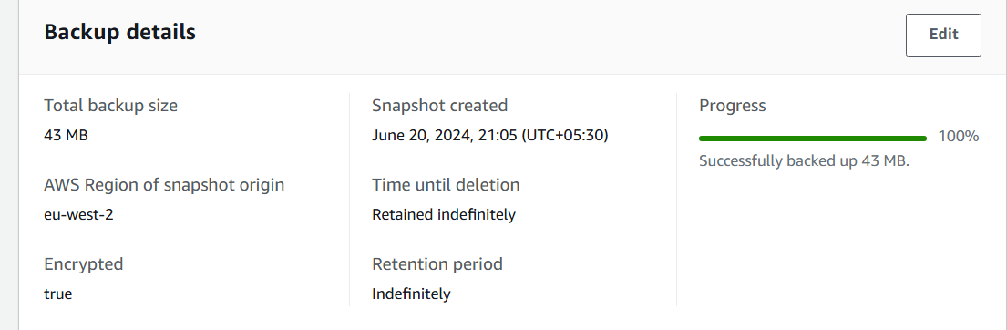

3.4 restore using

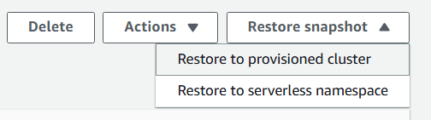

3.5 Amazon Redshift creates a new cluster, fill these to make that clustter

As part of this process, you can change parameters such as the node type, Availability Zone, and security groups. You cannot change the number of nodes during a restore process.

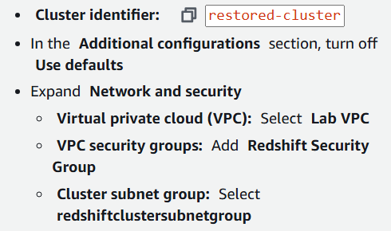

3.6 

3.7 2 clusters

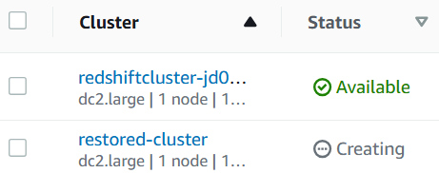

**Task 4: Restoring a table from a snapshot**

4.1 limits

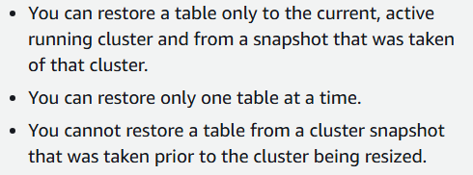

4.2 in org cluster, restore table

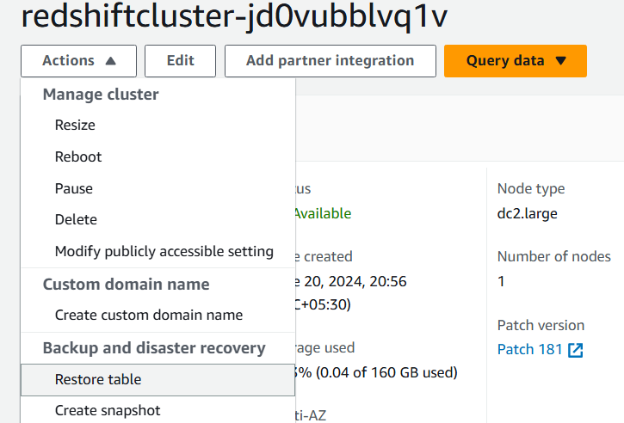

4.3 choose the snapshot

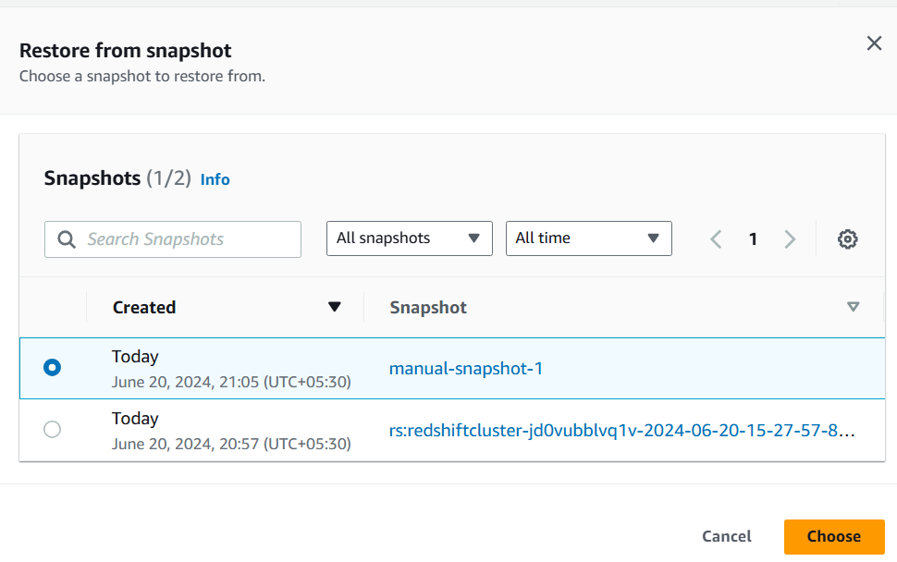

4.4

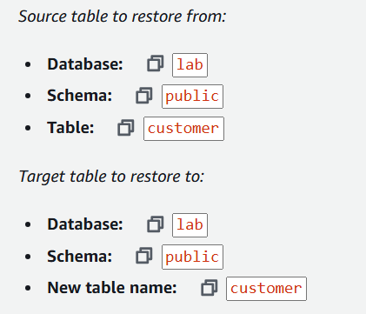

4.5 run to verify

*SELECT * FROM customer*

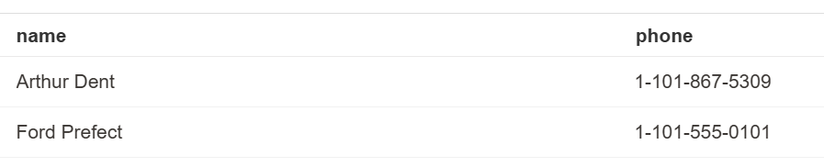

**Task 5: Connecting to the restored cluster**

5.1 open the new cluster

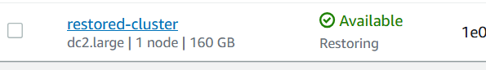

5.2 use the endpoint value to connect to this cluster

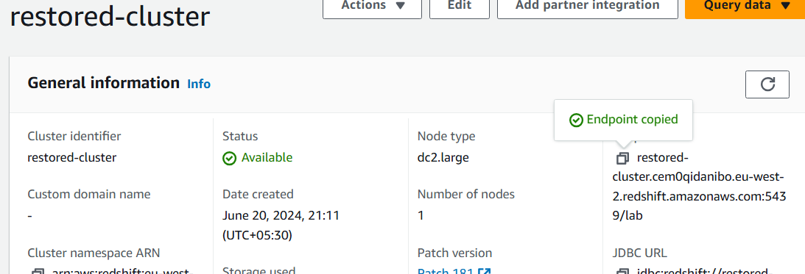

restored-cluster.cem0qidanibo.eu-west-2.redshift.amazonaws.com:5439/lab

5.3 pgweb

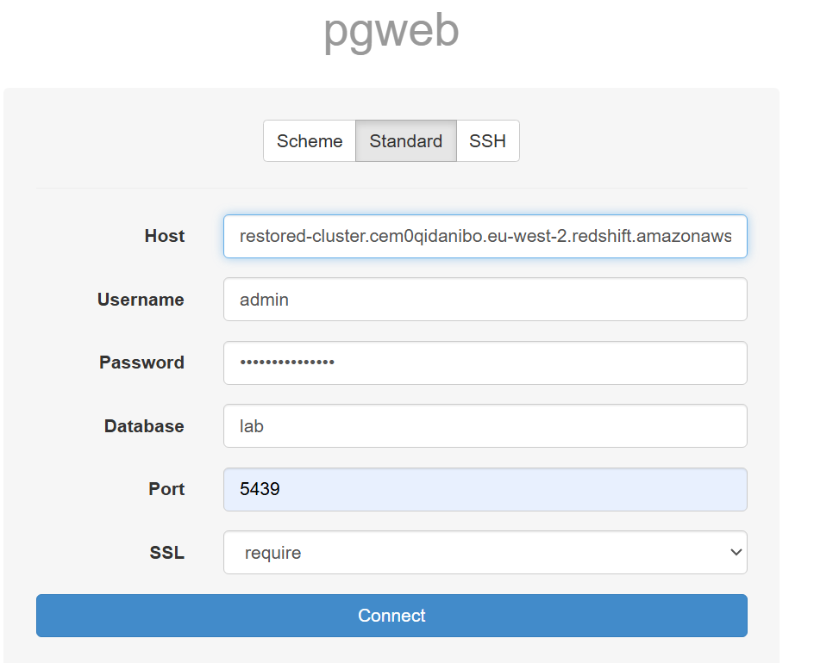

5.4 this cluster works too

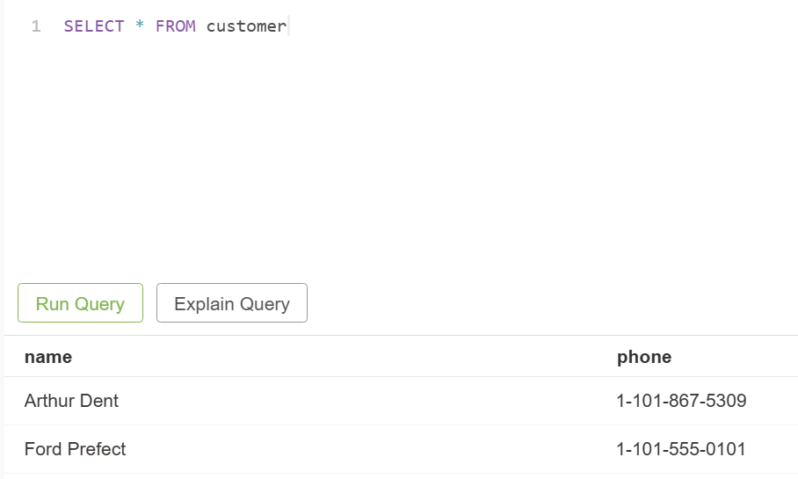

5.5 use this to try to restore the non-backup-ed table

*SELECT * FROM report_staging*

